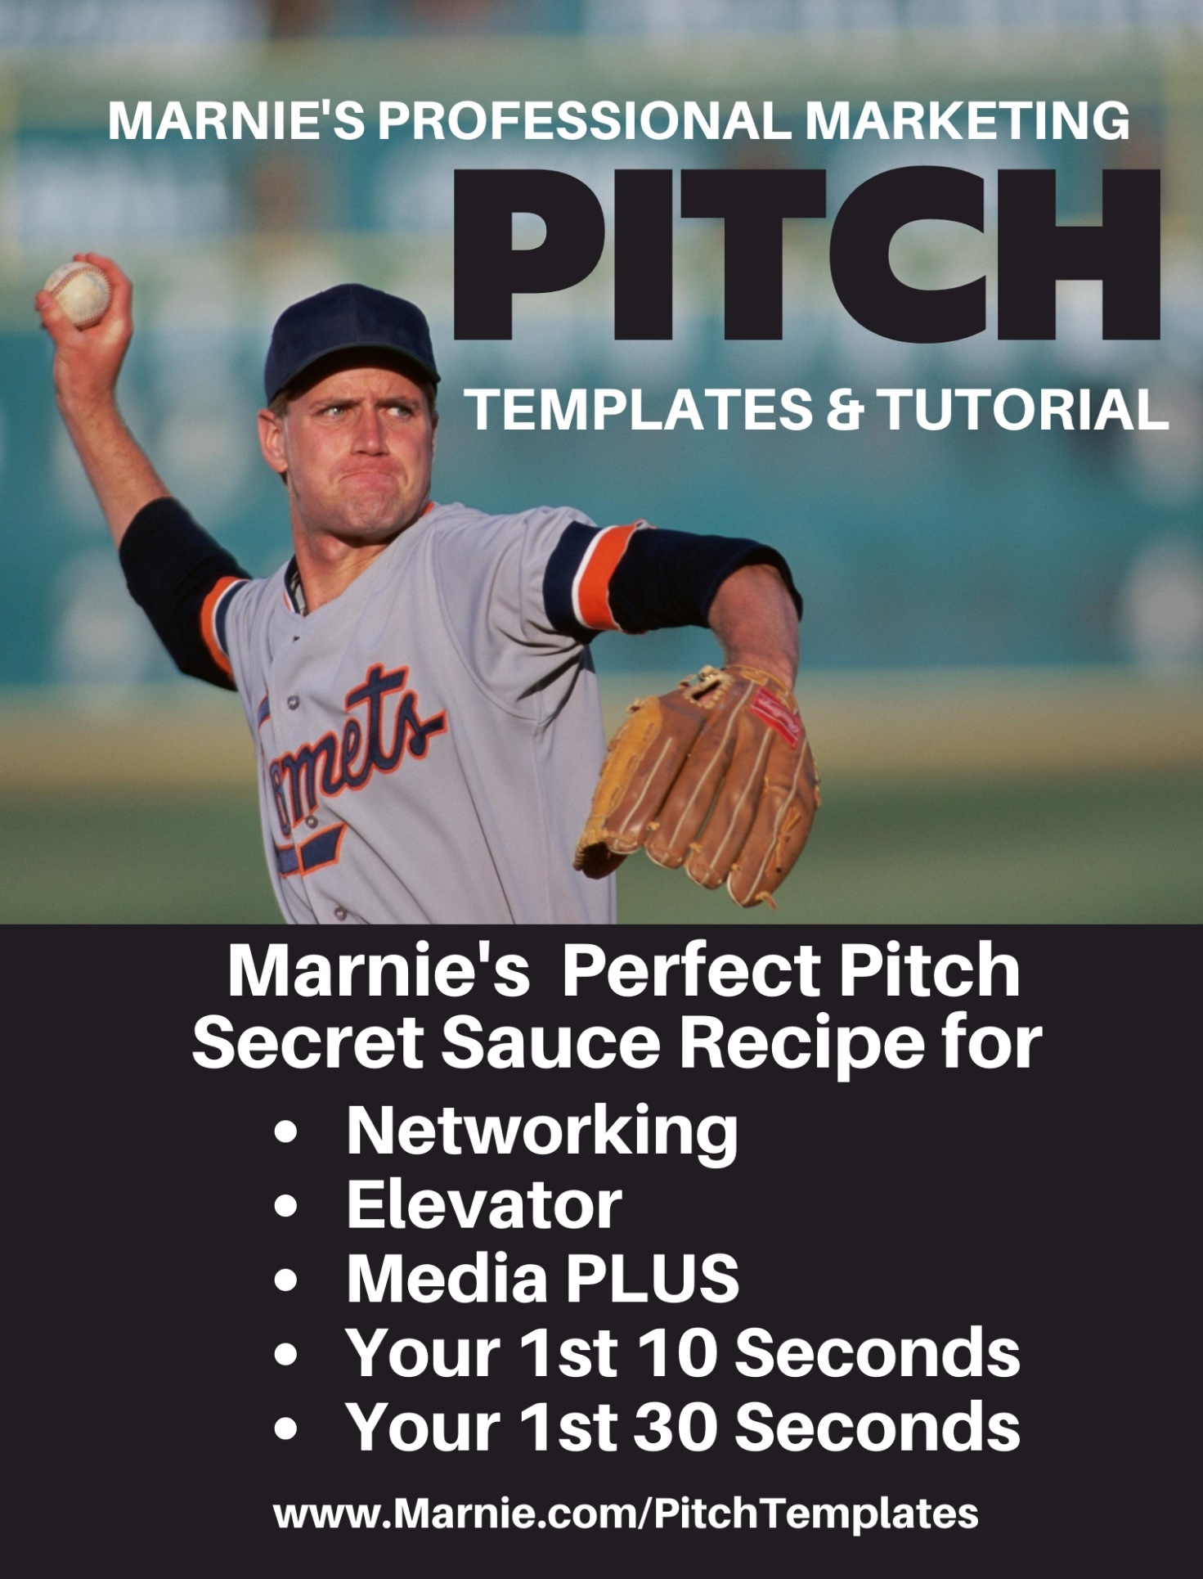
Pitch Templates
How to prepare amazing, action-inspiring pitches prior to needing them!

You may potentially need dozens or hundreds of pitches during your lifespan. Mastering the art of the pitch NOW is brilliant, and once you’re comfortable with the process, you’ll be able to create rock-star pitches in as little as five minutes.

Let’s dissect the types of pitches this program covers and then get your going!

Elevator Pitch | You’re in an elevator when the doors open and the President of the United States climbs in. He looks directly at you and says, “Hi! I don’t think we’ve met. Who are you?”
Networking Pitch | Everyone’s got 30 second to introduce themselves and your turn is coming. Whatcha gonna say that inspires action?
Media Pitch | You’re at a meet and greet with media bookers and you get 30 seconds to pitch your idea. Are you ready?
Job Interview Pitch | You’re in the supermarket checkout when you realize you’re having a casual conversation with the CEO of your dream employer. What’s your pitch?
Project/Idea Pitch | You’ve come up with the BEST idea ever and you find yourself facing the very person who could make it happen. Are your words ready?
Collaboration Pitch | You’re in the greenroom with the most famous person you’ve ever met. Your missions align. Are you going to pitch a collaboration or shrink like an unprepared coward?

Once you understand how to create your 10 and 30-second pitches, the sky’s the limit. Because, literally, after that, the other person is driving the conversation and you are following their lead.

This is the most comfortable, easy and enjoyable pitch process ever. And there’s only one other thing you need to address in order to ensure your success.

You Are OK Either Way!

People are attracted to confidence and repelled by conflict. You have to get OK with being OK either way.

- They owe you nothing.
- They didn’t even know you existed this morning.
- You’ve never had their support before now.
- If they reject you, either they weren’t ready for you, you for them, or you should never work together (and there could be a thousand reasons).
- You are perfectly fine with or without their approval or partnership.

I personally know several people who’ve been on Good Morning America, Oprah and other major shows, who weren’t ready and it did them no good.

Instead of hooking all your dreams to single star, explore the galaxy to identify stars in alignment with yours RIGHT NOW.

There are individuals, companies and organizations who are ready for what you have to offer, at the level you can offer, right now. And there’s no shame in that!

To pull off a perfect pitch, you have to believe in yourself, in the natural progression of things, and in what you have to offer.

Ie – You can’t learn to run until you’ve learned to walk. Keep working on yourself and your offerings until you can enthusiastically embrace these facts about each:

True | No Yet | Fact
 |  | God created me and my service for such a time as this.
 |  | I LOVE what I do/provide and am really good at it.
 |  | People who have worked with me, rave about the results.
 |  | I’m comfortable with the price I charge for the results I deliver.
 |  | Others offer similar services, but nobody does it just like me.
 |  | I’m excited to get up every morning and pitch perfectly!
The other thing that repels potential collaborators, appearing as fear-based thinking, is a scarcity mentality. Test your thinking:

Scarcity | Plenty
I need this in order to be OK. | I was OK before, I’ll be OK either way.
I can’t handle rejection. | Rejection is a signal of a mismatch.
If I miss this, I’m out of luck. | There are plenty more opportunities out there.
If I mess this up, I’ll get blacklisted for life. | Even if I get blacklisted with this group, there are many, many more.
Failure is unacceptable. | Failure is necessary and provides helpful feedback.

The perfect pitch from a faith-filled heart results in matches made in heaven.

10 Second Pitch Template

You have 10 seconds to lock-in a great first impression and secure the full attention of your new connection.

Use this template to create every 10-second pitch you’ll need to succeed in any known environments. Here are three samples from my arsenal:

Environment | 10-Second Pitch
Sample 1 | I create winning media and marketing  pitches for thousands of paying clients  to insure they never miss any opportunity to present an awesome and outcome-shifting 1st impression.
Sample 2 | I’m the leadership mentor to over 15,000 leaders from 35 countries providing perspective transforming aha moments that radically change every future experience.
Sample 3 | I’m the founder and director of WomenSpeakers.com, connecting over 1000 speakers with thousands of planners across America.

You need a new pitch for every product, service, book launch, etc. But, for now, create you MASTER pitches that you’ll use in most situations.

Brainstorm the five most important environments for which you’ll need a prepared pitch. Include networking situations, online profiles that allow 30 words or less, media pitch emails or any situation in which you’ve been caught flat-footed without a polished, professional response to the question: What do you do, offer, speak on or whatever?

TABLE 1. Pitch Environments
My most important pitch environments:

Now, fill in the blanks below. The key is to focus on the facts that would IMPRESS a new connection. Now is not the time or place to be bashful or to submerge information they need to know. You have 10 seconds to knock their socks off!

TABLE 2. Determining your angle options.
# | Your WOW-producing facts, results, stats and proofs. | # | Audiences you serve. | # | Titles, adverbs and adjectives that you frequently use.

Add numbers beside each item above for identification purposes only. You are not giving a “value” here, just simplifying functionality. Start with your left column, top item, as #1 and proceed in order.

TABLE 3. Putting it all together. Which #s go with which environments.
Environment | WOW Items #s | Segment #s | Descript #s

Your mission is to combine these into 30 word wonders you can memorize and share easily anytime the opportunity arises.

CREATING YOUR 10-SECOND PITCHES
Copy (Ctrl C) and paste (Ctrl V) each line from TABLE 3 above.

#1 – I will use this pitch when __________________________________________

Environment | WOW Items #s | Segment #s | Descript #s

I (am/do what):
(for/to/with whom):
(resulting in what):

Final phraseology:

#2 – I will use this pitch when __________________________________________

Environment | WOW Items #s | Segment #s | Descript #s

I (am/do what):
(for/to/with whom):
(resulting in what):

Final phraseology:

#3 – I will use this pitch when __________________________________________

Environment | WOW Items #s | Segment #s | Descript #s

I (am/do what):
(for/to/with whom):
(resulting in what):

Final phraseology:

#4 – I will use this pitch when __________________________________________

Environment | WOW Items #s | Segment #s | Descript #s

I (am/do what):
(for/to/with whom):
(resulting in what):

Final phraseology:

#5 – I will use this pitch when __________________________________________

Environment | WOW Items #s | Segment #s | Descript #s

I (am/do what):
(for/to/with whom):
(resulting in what):

Final phraseology:

The beauty of this template is that you can use it over and over for every new product, resource and skill set, personalizing it for every environment you encounter.

Never again be caught without a riveting, WOW-inspiring response to a simple, sincere inquiry from a potential friend, client, collaborator or booker.

30 Second Pitch Template

Every 30-second pitch is a combination of a 10-second pitch plus 20 seconds (or 45 words) about the person with whom you’re connecting.

Copy and paste your first 10-Second Pitch here:

Your goal for the next 20-45 words is to segue into a conversation all about them, completely avoiding the words I, me, mine, ours, etc. From second 11 and onward, your entire attention is focused on them.

Here are the 30-word renditions of my three examples:

10-Second Pitch | Segue | 20-Second Follow-Up
I create winning media and marketing pitches for thousands of paying clients to insure they never miss any opportunity to present an awesome and outcome-shifting 1st impression. | With your experience, I bet you always feel confident, | But most people find themselves stumbling over their words or feeling ill-prepared when facing an opportunity to pitch their ideas, mission or vision.  STOP. I DON’T ASK THE OBVIOUS (to me) QUESTION. I JUST STOP and let them direct the conversation from here on out.
I’m the leadership mentor to over 15,000 leaders from 35 countries providing perspective transforming aha moments that radically change every future experience. | You probably have coaches and mentors who assist you, but | Most leaders feel lonely, misunderstood and frequently over-their-heads, in the deep end of whatever new project their floating at the moment.  STOP. I DON’T ASK THE OBVIOUS (to me) QUESTION. I JUST STOP and let them direct the conversation from here on out.
I’m the founder and director of WomenSpeakers.com, connecting over 1000 speakers with thousands of planners across America. | You’re probably fully booked and don’t have room for any engagements just now, but | Most speakers find themselves with some open weekends they’d like to fill and, after doing everything they know to do, don’t know how to find additional speaking opportunities to fill out their calendars.  STOP. I DON’T ASK THE OBVIOUS (to me) QUESTION. I JUST STOP and let them direct the conversation from here on out.

THE SEGUE & THE STOP

Once you understand the importance of shifting the focus off of you within the first 20 seconds, you’ll have no trouble seeing how to segue into your full stop.

The only way to mess up your pitch is to stay focused on what you offer without discovering their immediate pain points and needs. And, even when you do, remember, they already know and like you, let them come to trust you and pursue you instead of focusing on closing a deal.

Trust is built as they hear more stories about people you’ve served who are just like them. It’s that simple.

CREATING YOUR 30-SECOND PITCHES
Copy (Ctrl C) and paste (Ctrl V) your 10 second pitch from the 10-Second Pitch Template document.

Once you do a few of these, you’ll be an old-hand, ready to knock out news ones as needed, and finding yourself using this process in every conversation you have, regardless of how long you’ve known the person.

We start with WOW, and 10 seconds later, are all about THEM!

10-Second Pitch | Segue | 20-Second Follow-Up
 |  | STOP. DON’T ASK THE OBVIOUS (to you) QUESTION. JUST STOP and let them direct the conversation from here on out.
 |  | STOP. DON’T ASK THE OBVIOUS (to you) QUESTION. JUST STOP and let them direct the conversation from here on out.
 |  | STOP. DON’T ASK THE OBVIOUS (to you) QUESTION. JUST STOP and let them direct the conversation from here on out.

Templates are so fun because you can use them over and over for every new product, resource and skill set, personalizing each for every new life scenario.

Never again be caught without a riveting, WOW-inspiring response to a simple, sincere inquiry from a potential friend, client, collaborator or booker.

