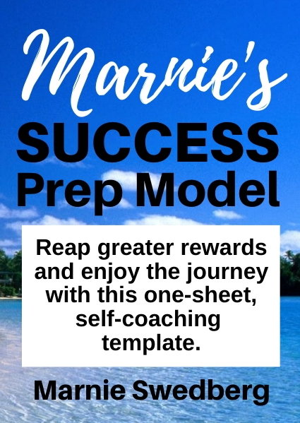
Welcome to the
S.U.C.C.E.S.S.
Prep Model

In order to reap the most rewards, and thoroughly enjoy the journey, this self-coaching template is the exact model I use before starting any new project myself, and what I use with my coaching and consulting my clients.

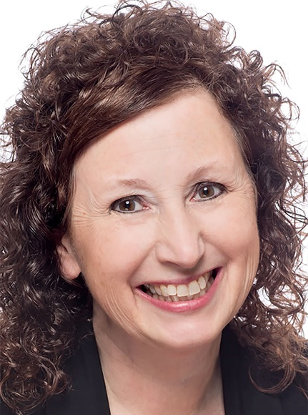
Whether you’re thinking of writing a new book, planning a conference, or launching a business or ministry, go through the SUCCESS model first. I keep blank copies of the middle two pages of this template (a front and back one-sheet) in my desk drawer so I can grab and brainstorm every project before I start it.

I also use this template when I’m working with the event coordination team of the events I speak at in the US and worldwide. It’s amazing to see how much low-hanging fruit has never been gathered, even by veteran planners.

Completing the worksheet might take 15 minutes or three hours, depending on how many times you’ve done projects like you new venture before, and if you have your mission/vision work done in advance.

However long it takes the first time, it will take less and less time with each future use, as you get accustomed to thinking like this.

Why not insure the greatest possible returns on your investments of time, money and relationship?

When you add these seven steps to your process, you’ll exponentially increase both the likelihood and level of your success, so now’s the time to establish a clear path, release unnecessary baggage and attract your ideal partners for the journey.

S – Start with a clear vision & mission statement.
I create a new vision and mission statement for every new project. Each provides clear direction, but also sets the parameters (so the project doesn’t morph into a monster). If you have an easy method for creating mission/vision statements, great. If not, I offer a one-page process HERE. Add your vision and mission statements for your new thing here.

U – Uncover potential marketing, collaboration and income opportunities.
Who can help you make this the biggest and the best it can be? Now’s the time to brainstorm every potential marketing opportunity, collaborator and upsell/add-on. Write all your ideas below.

C – Clarify your audiences.
My #1 Amazon Best Seller, eBooks: Idea to Amazon in 14 Days, includes the strategy of writing your next book with three audiences in mind: The readers (of course), but also the media (who can help you promote it) and potential publishers (who can get your book everywhere). Get crystal clear about every person, group, organization, industry or nation that could benefit from you doing this project. This will help you build a big enough foundation to accommodate the largest growth possible.

C – Chart a reasonable path.
C – Clear path.
Envision your desired outcome, and then, starting from the end, work backwards to list everything that needs to happen between there and here, where you are today.

E – Establish a timeline with target dates.
Using your deadline and the above list of projects, create a timeline with target due dates.

S – Simplify wherever you can.
Review your path and timeline. Is there anything that is unnecessary? Keep the things that are truly important to you (because they’re critical or simply because they bring you joy) and get rid of the rest.

S – Surround everything with prayer.
There is no comparison to a project done without God and one surrounded by His love, involvement and blessing. You’ve created a plan, now lay it before Him and ask Him for final input, direction, vetoes and clarifications. Ask God to give you a “theme verse” for this project, and then keep conversing with Him along the way, following His lead.

This SUCCESS Prep Model works wonders at revealing which projects you should and shouldn’t start, and how to maximize the outcomes of the ones you choose to pursue.

Want to Collaborate?

As an “aha” generator and perspective transformation speaker and consultant, my passion is seeing lightbulbs go on for YOU!
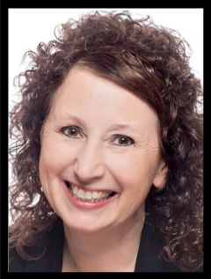
- Pitch a show topic idea to be considered as a guest on my radio show and/or invite me to be on yours. www.Marnie.com
- Invite me as a speaker for your conference, or register to be a speaker, or find a speaker at www.WomenSpeakers.com.
- Send me to your favorite indigenous mission group to do a conference and leadership training or sponsor me to go for others.
- Include me in your Online Summit or pitch us to be part of my Marketing Masterminds.
- Schedule a time for me and your worship team to work together to record and publish newly written praise songs.
- Engage me to provide Internet one-on-one or group consulting anytime you need a little extra support.

When God strung together your 3-billion pair of DNA, He did it in a particular way.
You are unique. Your ideas aren’t like anyone else’s. Even the way you pursue your dream is exclusive to you.

My heart is to help you discover and embrace His unique plans and projects for you.

My background includes owning and overseeing businesses in four industries: Health/Fitness, Retail, Restaurant and Online Marketing. I’ve been featured on over 700 media outlets, enjoy Amazon Best Seller status, host a #1 ranked Blog Talk Radio show, and am the founder/director of the largest online directory of its kind in the world.

Last year, I solo-circumnavigated the globe on a three-week mission trip, visiting five continents and speaking in four countries, for a total of 35 presentations including six conferences to women, business and ministry leaders and government officials.

If I can be of any further assistance, just let me know!

God bless!
Marnie
https://www.Marnie.com

