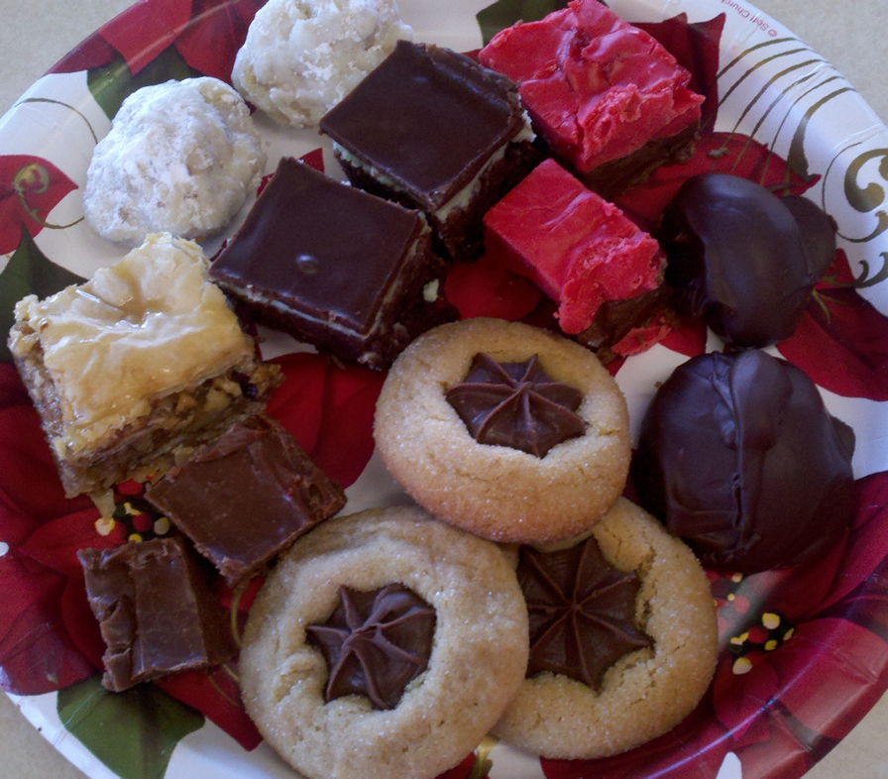
Mega
Christmas
Baking Day
by Marnie Swedberg / www.Marnie.com
- Baklava* – Greek pastry (diamond, gold, crispy)
- Truffles (round, chocolate, smooth)
- Fudge (square, chocolate, smooth)
- Mint Brownies* (square, chocolate & green, brownie)
- Russian Tea Cakes* (round, white, cookie)
- Star Cookies* (stars, gold & chocolate, cookie)
- Cherry Delights (square, chocolate & red, smooth)
*Requires oven.

What I plan to make later:
Chocolate Dipped Strawberries (fresh day-of, triangle, chocolate, red & green)
Sugar Cookies (with kids, multi-shapes & colors, cookie)
Almond Brittle (with family Christmas Eve, tradition, hard)

Steps:
- Turn on the Christmas music. Take out all ingredients, utensils and supplies.
- Preheat oven & assemble Baklava. Bake 1 hour. While baking:
- Start truffles and start 1st freeze.
- Make fudge. Set aside.
- Assemble brownie mix in pan.
- Heat honey drizzle.
- Remove Baklava from oven and put in brownies.
- Cut and drizzle Baklava.
- Assemble Russian Tea Cakes and put in fridge to chill.
- Assemble Star Cookie ingredients, roll enough to fill 2 cookie sheets.
- Remove brownie mix from oven and put in 1st two trays of cookies.
- Set brownies aside to cool. Assemble 2 more trays of cookies.
- Replace 1st cookies with 2nd and star 1st. Set aside.
- Continue rotations until Star cookies are done.
- Begin rotations of Russian Tea Cakes until all are baked.
- Between batches of cookies above, make 2 types of frosting for brownies.
- Apply 1st layer of frosting.
- Roll frozen truffles and return to freezer.
- Assemble Cherry Delights.
- Cut fudge.
- Place cooled star cookies into freezer for 1 minute to firm the stars (for stacking).
- Put all cookies into clean empty ice cream buckets or similar airtight containers.
- Apply 2nd layer frosting to brownies and put in fridge for 10 minutes.
- Melt truffle chocolate and roll truffles. Retain at room temp now until served.
- Cut brownies.
- Make your 1st combo tray and set it somewhere you can see it!
- Celebrate your achievement as you finish and clean up the kitchen.

Baklava
Preheat oven to 300. Grease 9x13” pan.
Combine:
16 ounces chopped walnuts
½ cup sugar
1 teaspoon cinnamon
Cut in ½ (to create 8x12” sheets)
1 package phyllo dough
Cover as directed on package.
Layer one at a time:
5 individual sheets of phyllo into pan
Brushing each with butter from
1 cup melted butter
Evenly sprinkle with ¼ of the sugar and nut mix.
Repeat 4x, ending with a layer of buttered phyllo.
Cut diagonally (to create diamonds) ½ way through with sharp knife.
Bake 1-1/4 hours.
Immediately drizzles with
1 cup melted honey
Cool and finish cutting diamonds through to the bottom.
Store at room temperature up to 3 weeks.
Optional:
Drizzle with melted chocolate chips.

Truffles
Combine and microwave for one minute:
12 ounces semi sweet chocolate chips
1 cup cream (heavy/whipping cream)
2 Tablespoons butter
Stir until melted. Freeze 1 hour.
Roll into balls. Freeze 1 hour.
Roll balls into unsweetened cocoa powder, powdered sugar, chocolate shot or melted chocolate chips.
Blue Ribbon Fudge
Combine in saucepan and bring to boil:
12 ounces evaporated milk
4-1/2 cups sugar
Boil 9 minutes, stirring constantly.
All at once add:
6 cups chocolate chips (3 pkgs)
8 ounces marshmallow cream
1 cup butter, room temp (heat in micro 10 seconds)
Optional: 4 cups chopped nuts
Pour into 9x13” pan. Set aside to cool. Cut later.

Peppermint Brownies

Brownie Layer
Your favorite boxed mix, replacing the vanilla with peppermint extract OR
Stir just until blended:
1 cup shortening
4 eggs
1 cup flour
½ teaspoon salt
2 cups sugar
¾ cup cocoa
1 teaspoon peppermint extract
Bake in greased 9x13” pan in preheated 350°F oven for 30 minutes (or until toothpick inserted near center comes out clean).

Middle Layer
Beat until creamy:
2 cups powdered sugar
½ cup softened butter
1 tablespoon water
1 teaspoon peppermint extract
3 drops green food coloring
Layer onto cooled brownies.

Top Layer
Melt together:
1 cup semi-sweet chocolate chips
8 tablespoons butter
1 teaspoon peppermint extract
Stir until smooth.
Spread over green layer.

Russian Tea Cakes

Combine with mixer:

1 cup butter, room temp (micro 10 seconds)

½ cup powdered sugar

1 teaspoon vanilla

In separate bowl combine:

2-1/2 cups flour

¼ teaspoon salt

¾ cup finely chopped walnuts

Combine and chill for 30 minutes.

Roll into 1” balls.

Bake on ungreased cookie sheet, very close together

But not touching, at 365 for 8-12 minutes.

Immediately upon removal from oven, while still warm,

roll in powdered sugar.

Star Cookies
Combine and beat with mixer:
1 cup butter, room temp (micro 10 seconds)
1 cup peanut butter
1 cup brown sugar
1 cup white sugar
2 eggs
¼ cup milk
1 teaspoon vanilla
In separate bowl combine:
3-1/2 cups flour
2 teaspoons soda
½ teaspoon salt
Add to sugar ingredients and combine with mixer
until smooth.
Shape into balls.
Roll in white sugar and bake at 325 for 6-8 minutes.
Remove from oven and press immediately with
Chocolate stars
Cool on racks. Chill in freezer for 2 minutes before
stacking (to firm the chocolate stars).

Cherry Delights
Melt in microwave 1 minute:
1 cup chocolate chips
½ cup peanut butter
Stir to blend then spread in 8 or 9" square.
Combine in saucepan:
1 cup sugar
2 Tablespoons butter
1/3 cup cream
Boil on high heat for about 5 minutes, stirring occasionally.
Remove from heat and immediately stir in
1 cup mini marshmallows
1 cup cherry chips
Stir until melted and smooth.
Pat evenly over chocolate layer.
Drizzle with
½ cup chocolate chips, melted
Chill in refrigerator until set. Cut into 1" squares.

Grocery List

Small amounts:
Salt, baking soda, green food coloring, cinnamon, peppermint & vanilla extracts
Sugars:
11 cups white
1 cup brown
1.5 cups powdered
Brownie Mix OR Shortening: 1 cup
Eggs: 2-6
Marshmallow Cream
Mini Marshmallows
Chocolate stars: 1 bag
Honey: 1 cup
Peanut Butter: 1.5 cups
Flour: 7 cups

Baking chips:
12 cups (6 12 oz. bags) chocolate
1 cup cherry
Unsweetened cocoa: ¾ cup
Walnuts, chopped: 1.5 pounds
Butter: 7 cups
Milks:
12 ounces evaporated
1.33 cups heavy cream
¼ cup milk
Frozen Phyllo Dough: 1 box
Christmas Petit Four Cups
Gallon ziptop bags
Plastic Wrap
Disposable Christmas Plates

